**Project Schedule**

**and**

**Work Breakdown Structure (WBS)**

**ACC BCC Expansion Project**

**American Chemet Corporation**

**145 Highway 282**

**East Helena, MT 59635**

**May/02/2025**

**Introduction**

The Project Schedule and Work Breakdown Structure presented here represent all the work required to complete this project. The Project Schedule is represented with a Gantt Chart and PERT Diagram.

**Gantt Chart**

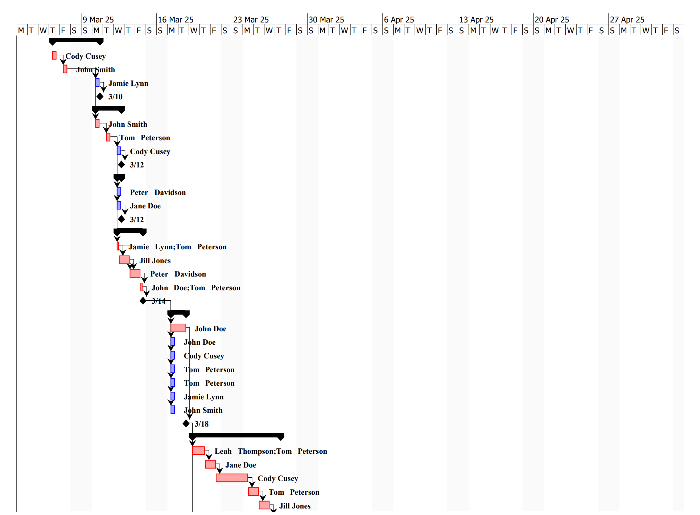

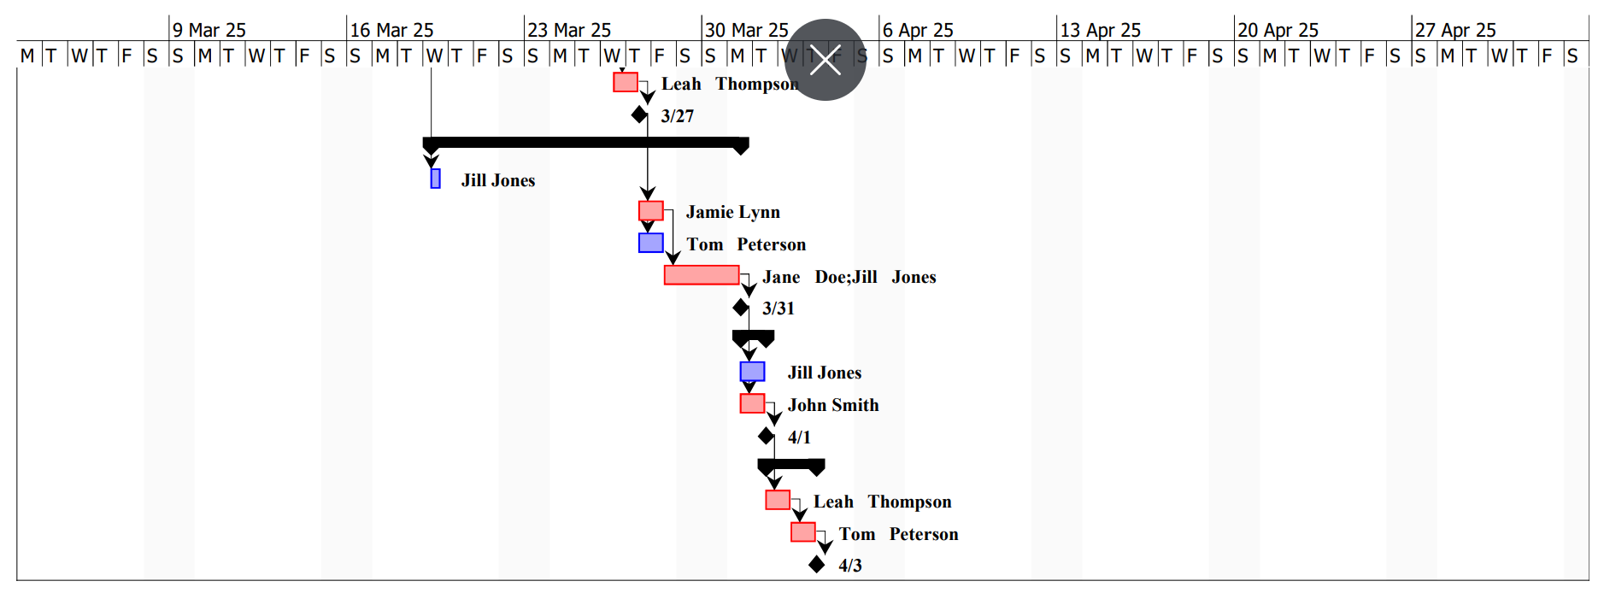

**PERT Diagram**

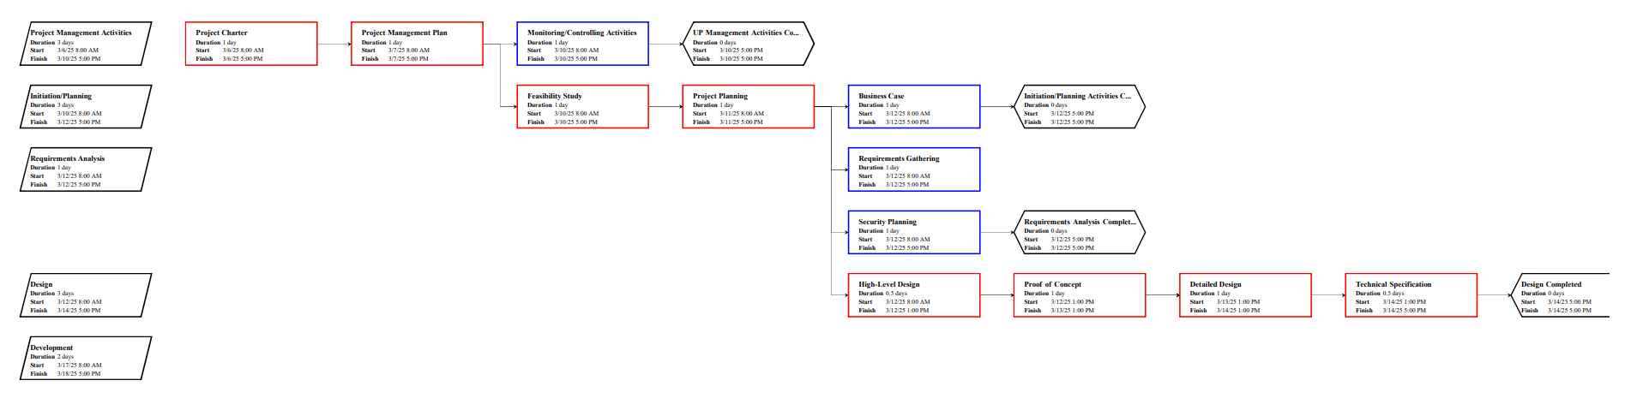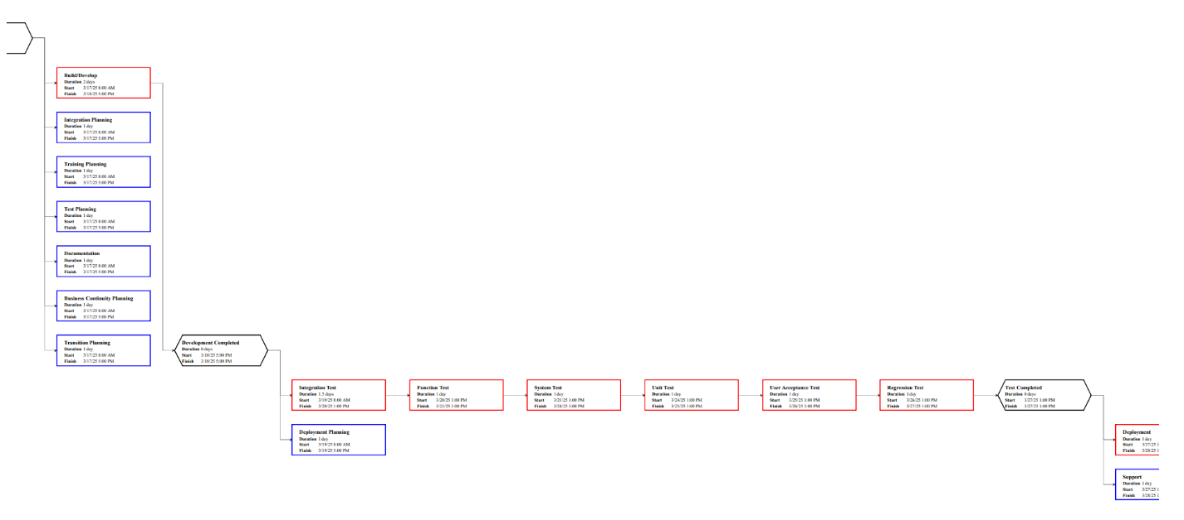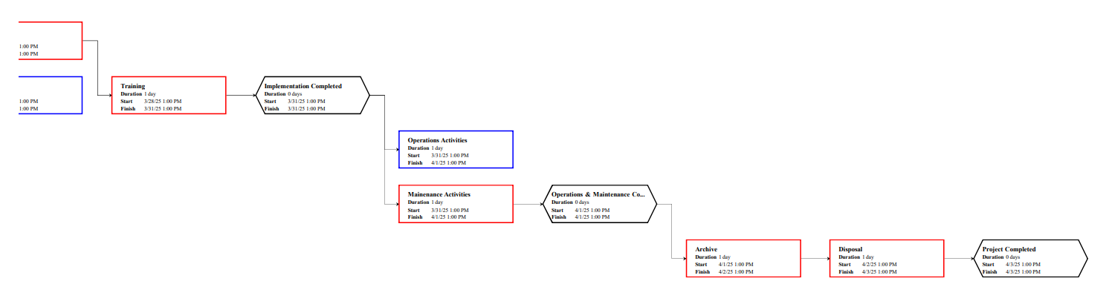

**Outline View**

1. ACC BCC Expansion
   1. Initiation
      1. Evaluation & Recommendations
      2. Develop Project Charter
      3. *Deliverable:* Submit Project Charter
      4. Project Sponsor Reviews Project Charter
      5. Project Charter Signed/Approved
   2. Planning
      1. Create Preliminary Scope Statement
      2. Determine Project Team
      3. Project Team Kickoff Meeting
      4. Develop Project Plan
      5. Submit Project Plan
      6. *Milestone:* Project Plan Approval
   3. Execution
      1. Project Kickoff Meeting
      2. Confirm Deliverables and Deadline
      3. Design Build Out
      4. Procure Critical Components
      5. Procure Contracted Services
      6. Installation Phase
      7. Testing Phase
      8. User Training
      9. Go Live
   4. Control
      1. Project Management
      2. Project Status Meetings
      3. Risk Management
      4. Update Project Management Plan
   5. Closeout
      1. Audit Procurement
      2. Document Lessons Learned
      3. Update Files/Records
      4. Gain Formal Acceptance
      5. Archive Files/Documents

**Hierarchical Structure**

|  |  |  |
| --- | --- | --- |
| Level | WBS Code | Element Name |
| 1 | 1 | ACC BCC Expansion |
| 2 | 1.1 | Initiation |
| 3 | 1.1.1 | Evaluation & Recommendations |
| 3 | 1.1.2 | Develop Project Charter |
| 3 | 1.1.3 | Deliverable: Submit Project Charter |
| 3 | 1.1.4 | Project Sponsor Reviews Project Charter |
| 3 | 1.1.5 | Project Charter Signed/Approved |
| 2 | 1.2 | Planning |
| 3 | 1.2.1 | Create Preliminary Scope Statement |
| 3 | 1.2.2 | Determine Project Team |
| 3 | 1.2.3 | Project Team Kickoff Meeting |
| 3 | 1.2.4 | Develop Project Plan |
| 3 | 1.2.5 | Submit Project Plan |
| 3 | 1.2.6 | Milestone: Project Plan Approval |
| 2 | 1.3 | Execution |
| 3 | 1.3.1 | Project Kickoff Meeting |
| 3 | 1.3.2 | Confirm Deliverables and Deadline |
| 3 | 1.3.3 | Design Build Out |
| 3 | 1.3.4 | Procure Critical Components |
| 3 | 1.3.5 | Procure Contracted Services |
| 3 | 1.3.6 | Installation Phase |
| 3 | 1.3.7 | Testing Phase |
| 3 | 1.3.8 | User Training |
| 3 | 1.3.9 | Go Live |
| 2 | 1.4 | Control |
| 3 | 1.4.1 | Project Management |
| 3 | 1.4.2 | Project Status Meetings |
| 3 | 1.4.3 | Risk Management |
| 3 | 1.4.4 | Update Project Management Plan |
| 2 | 1.5 | Closeout |
| 3 | 1.5.1 | Audit Procurement |
| 3 | 1.5.2 | Document Lessons Learned |
| 3 | 1.5.3 | Update Files/Records |
| 3 | 1.5.4 | Gain Formal Acceptance |
| 3 | 1.5.5 | Archive Files/Documents |

**Tabular View**

|  |  |  |
| --- | --- | --- |
| Level 1 | Level 2 | Level 3 |
| 1 ACC BCC Expansion | 1.1 Initiation | 1.1.1 Evaluation & Recommendations  1.1.2 Develop Project Charter  1.1.3 Deliverable: Submit Project Charter  1.1.4 Project Sponsor Reviews Project Charter  1.1.5 Project Charter Signed/Approved |
| 1.2 Planning | 1.2.1 Create Preliminary Scope Statement  1.2.2 Determine Project Team  1.2.3 Project Team Kickoff Meeting  1.2.4 Develop Project Plan  1.2.5 Submit Project Plan  1.2.6 Milestone: Project Plan Approval |
| 1.3 Execution | 1.3.1 Project Kickoff Meeting  1.3.2 Confirm Deliverables and Deadline  1.3.3 Design Build Out  1.3.4 Procure Critical Components  1.3.5 Procure Contracted Services  1.3.6 Installation Phase  1.3.7 Testing Phase  1.3.8 User Training  1.3.9 Go Live |
| 1.4 Control | 1.4.1 Project Management  1.4.2 Project Status Meetings  1.4.3 Risk Management  1.4.4 Update Project Management Plan |
| 1.5 Closeout | 1.5.1 Audit Procurement  1.5.2 Document Lessons Learned  1.5.3 Update Files/Records  1.5.4 Gain Formal Acceptance  1.5.5 Archive Files/Documents |

**Tree Structure View**

ACC BCC Expansion

1

Initiation

1.1

Planning

1.2

Execution

1.3

Control

1.4

Create Preliminary Scope Statement

1.2.1

Closeout

1.5

Evaluation & Recommendations

1.1.1

Develop Project Charter

1.1.2

Deliverable: Submit Project Charter

1.1.3

Project Sponsor Reviews Project Charter

1.1.4

Project Charter Signed/Approved

1.1.5

Determine Project Team

1.2.2

Project Team Kickoff Meeting

1.2.3

Develop Project Plan

1.2.4

Submit Project Plan

1.2.5

Milestone: Project Plan Approved

1.2.6

Project Kickoff Meeting

1.3.1

Confirm Deliverables and Deadline

1.3.2

Design Build Out

1.3.3

Procure Critical Components

1.3.4

Procure Contracted Services

1.3.5

Installation Phase

1.3.6

Testing Phase

1.3.7

User Training

1.3.8

Go Live

1.3.9

Project Management

1.4.1

Project Status Meetings

1.4.2

Risk Management

1.4.3

Update Project Management Plan

1.4.4

Audit Procurement

1.5.1

Document Lessons Learned

1.5.2

Update Files/ Records

1.5.3

Gain Formal Acceptance

1.5.4

Archive Files/ Documents

1.5.5

**WBS Dictionary**

| Level | WBS Code | Element Name | Definition |
| --- | --- | --- | --- |
| 1 | 1 | ACC BCC Expansion | All work to build out and implement a new expansion plant for BCC production. |
| 2 | 1.1 | Initiation | The work to initiate the project. |
| 3 | 1.1.1 | Evaluation & Recommendations | Working group to evaluate solution sets and make recommendations. |
| 3 | 1.1.2 | Develop Project Charter | Project Manager to develop the Project Charter. |
| 3 | 1.1.3 | Deliverable: Submit Project Charter | Project Charter is delivered to the Project Sponsor. |
| 3 | 1.1.4 | Project Sponsor Reviews Project Charter | Project sponsor reviews the Project Charter. |
| 3 | 1.1.5 | Project Charter Signed/Approved | The Project Sponsor signs the Project Charter which authorizes the Project Manager to move to the Planning Process. |
| 2 | 1.2 | Planning | The work for the planning process for the project. |
| 3 | 1.2.1 | Create Preliminary Scope Statement | Project Manager creates a Preliminary Scope Statement. |
| 3 | 1.2.2 | Determine Project Team | The Project Manager determines the project team and requests the resources. |
| 3 | 1.2.3 | Project Team Kickoff Meeting | The planning process is officially started with a project kickoff meeting which includes the Project Manager, Project Team and Project Sponsor (optional). |
| 3 | 1.2.4 | Develop Project Plan | Under the direction of the Project Manager the team develops the project plan. |
| 3 | 1.2.5 | Submit Project Plan | Project Manager submits the project plan for approval. |
| 3 | 1.2.6 | Milestone: Project Plan Approval | The project plan is approved and the Project Manager has permission to proceed to execute the project according to the project plan. |
| 2 | 1.3 | Execution | Work involved to execute the project. |
| 3 | 1.3.1 | Project Kickoff Meeting | Project Manager conducts a formal kick off meeting with the project team, project stakeholders and project sponsor. |
| 3 | 1.3.2 | Confirm Deliverables and Deadline | The original deliverable and deadline requirements are reviewed by the project manager and team, then validated with the stakeholders. This is where additional clarification may be needed. |
| 3 | 1.3.3 | Design Build Out | The technical resources design for the plant build out. Engineering blueprints, electrical requirements, IT infrastructure, and process flow diagrams all finalized. |
| 3 | 1.3.4 | Procure Critical Components | The procurement of all critical components. These would include, but not be limited to: custom fabrication, long lead time items, high cost items, ancillary equipment, and more. |
| 3 | 1.3.5 | Procure Contracted Services | The procurement of all contracted services. This includes bulk CO2 supply, O2 supply, Aqua Ammonia supply, and other process chemicals. Additionally, this includes on-site contractors to perform work such as: concrete, plumping, draining, electrical, and testing. |
| 3 | 1.3.6 | Installation Phase | The physical build out work is being performed. Concrete work done and site preparation, receipt and installation of critical components, plumbing the plant together, getting power to appropriate locations, IT systems, and more. |
| 3 | 1.3.7 | Testing Phase | After each iteration during the installation phase, testing needs to be done. Once entirely complete, formal production testing occurs. |
| 3 | 1.3.8 | User Training | All users are provided hands on training from engineers, facilities team, production supervisor, and external contractors. Formal SOP and instructions created and provided for future training and knowledge availability. |
| 3 | 1.3.9 | Go Live | System goes live to production. |
| 2 | 1.4 | Control | The work involved for the control process of the project. |
| 3 | 1.4.1 | Project Management | Overall project management for the project. |
| 3 | 1.4.2 | Project Status Meetings | Weekly team status meetings. |
| 3 | 1.4.3 | Risk Management | Risk management efforts as defined in the Risk Management Plan. |
| 3 | 1.4.4 | Update Project Management Plan | Project Manager updates the Project Management Plan as the project progresses. |
| 2 | 1.5 | Closeout | The work to close-out the project. |
| 3 | 1.5.1 | Audit Procurement | An audit of all hardware and software procured for the project, ensures that all procured products are accounted for and in the asset management system. |
| 3 | 1.5.2 | Document Lessons Learned | Project Manager along with the project team performs a lessons learned meeting and documents the lessons learned for the project. |
| 3 | 1.5.3 | Update Files/Records | All files and records are updated to reflect the widget management system. |
| 3 | 1.5.4 | Gain Formal Acceptance | The Project Sponsor formally accepts the project by signing the acceptance document included in the project plan. |
| 3 | 1.5.5 | Archive Files/Documents | All project related files and documents are formally archived. |

**Glossary of Terms**

Level of Effort: Level of Effort (LOE) is how much work is required to complete a task.

WBS Code: A unique identifier assigned to each element in a Work Breakdown Structure for the purpose of designating the elements hierarchical location within the WBS.

Work Package: A Work Package is a deliverable or work component at the lowest level of its WBS branch.

WBS Component: A component of a WBS which is located at any level. It can be a Work Package or a WBS Element as there's no restriction on what a WBS Component is.

WBS Element: A WBS Element is a single WBS component and its associated attributes located anywhere within a WBS. A WBS Element can contain work, or it can contain other WBS Elements or Work Packages.